**Technical Information and Code Set up**

* **Link to the IBM Watson Chat bot Preview:-**

<https://web-chat.global.assistant.watson.cloud.ibm.com/preview.html?region=eu-gb&integrationID=ba450a71-3571-43c7-9398-8d92d9e93e0b&serviceInstanceID=2c69cb0b-79ac-4a54-991a-79040e92a175>

*Test Data:-*

*Enter Cognizant Employee id: - 577295 or 849187 for testing purpose.*

* **Demo Video Link:-**

<https://youtu.be/GVaIL0jId3k>

* **The GitHub Repository consists of two code setup components:-**

1. A JSON File which packages the Skills of IBM Watson.
2. A Node.js file which consists the Code of the IBM Cloud function.

* **Steps to Set up and run the code:-**

1. Create an IBM Cloud Function Action - **Cloud_Functions_COVID**.

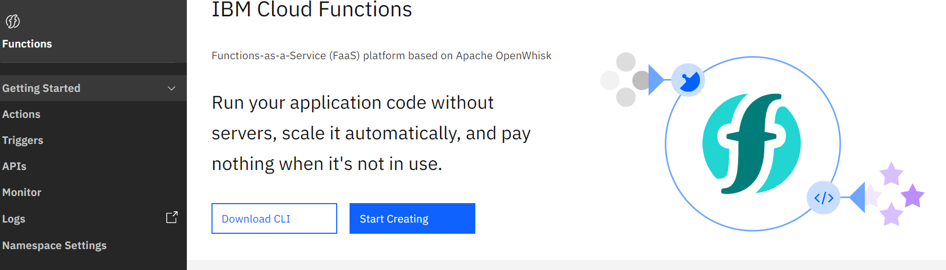

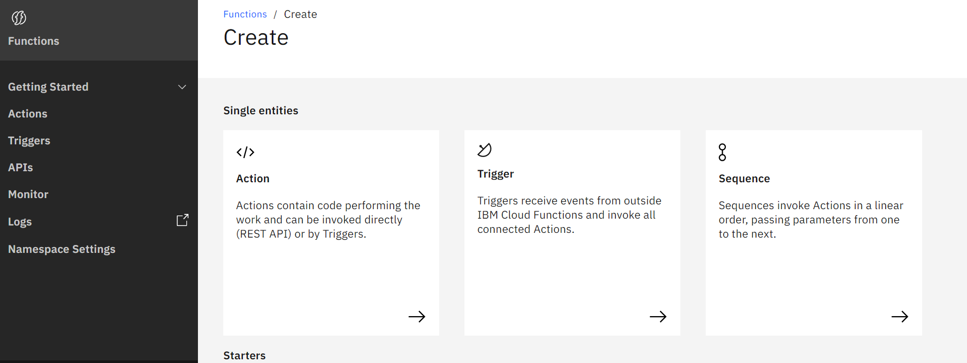

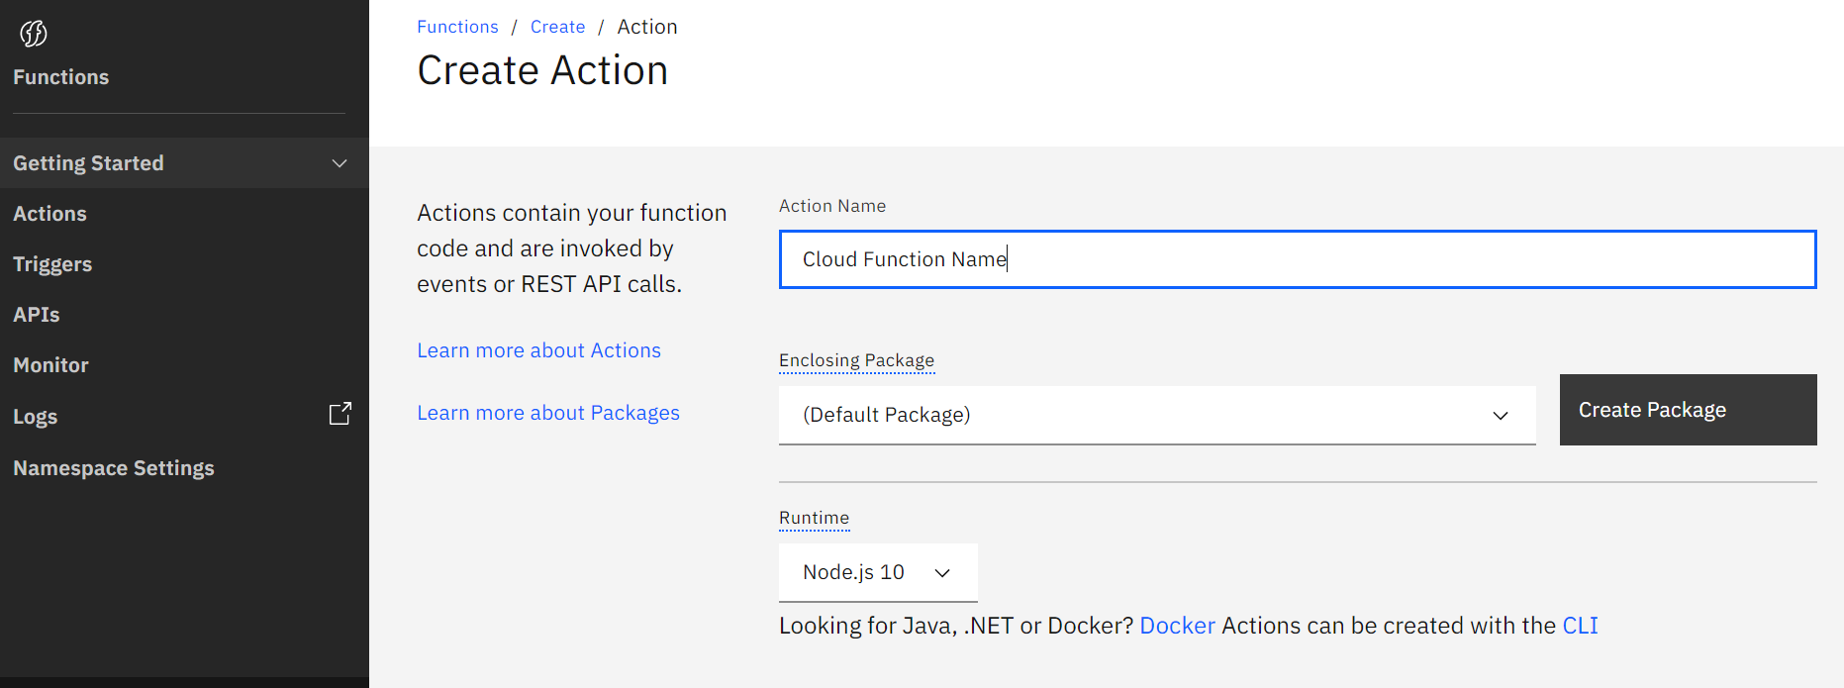

1. Copy the Node.js code in the cloud function and save.

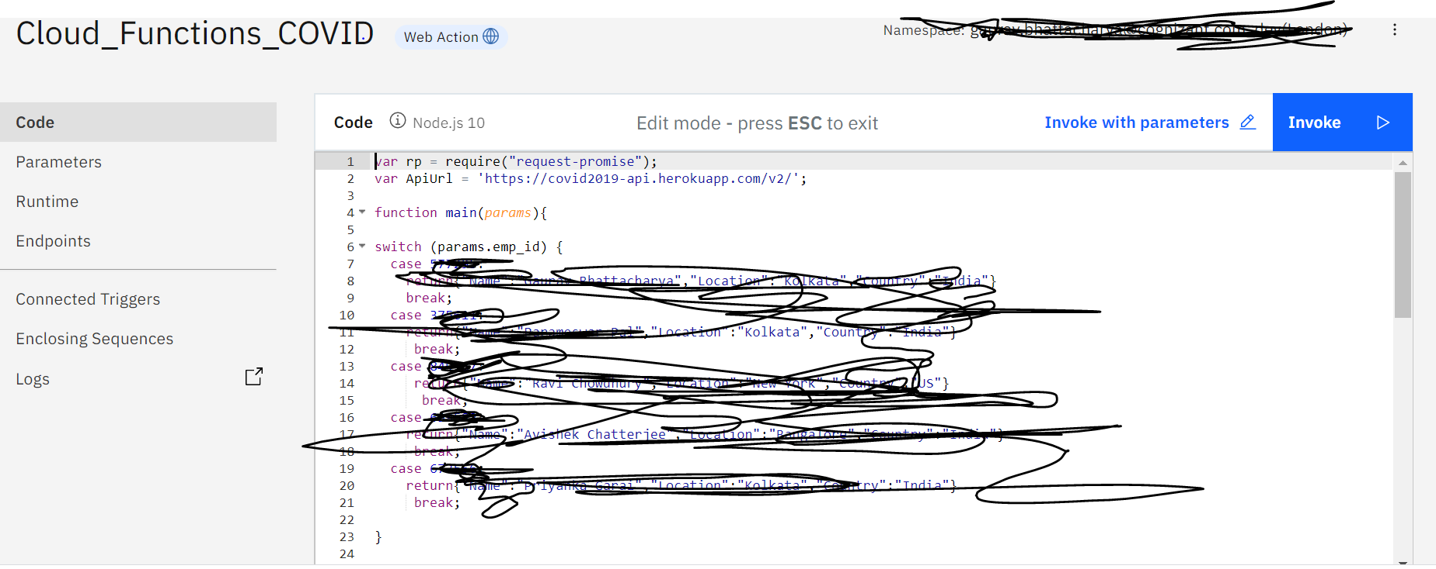

1. Enable Web Action:-

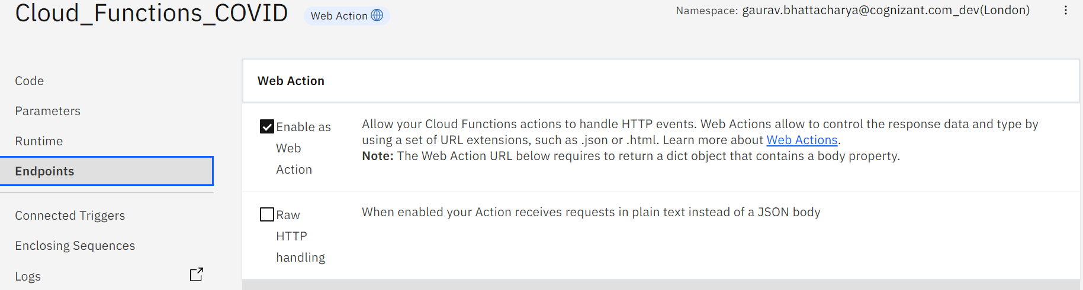

1. Create a Watson Assistant.

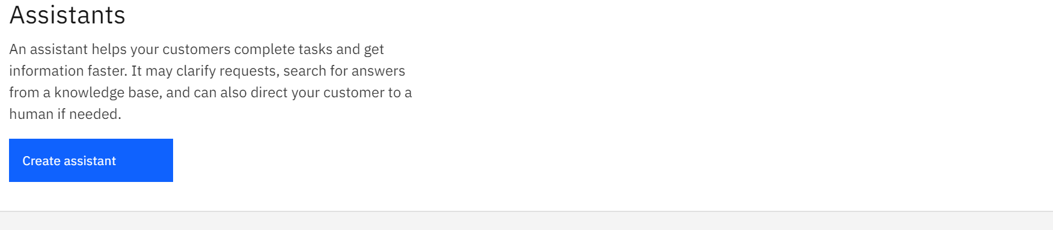

1. Import the Skills to the Watson Assistant to create the Chabot.

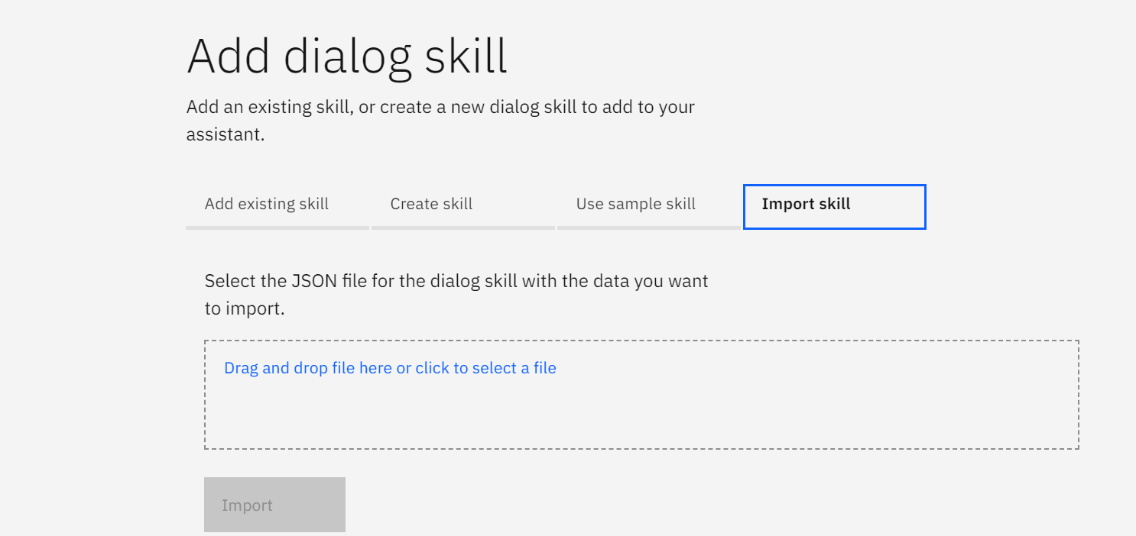

* **API used for fetching data:-**

<https://covid2019-api.herokuapp.com>

* **Architecture diagram:-**

